How to see who has signed in on a bill

On Legislature’s home page, leg.wa.gov, click on  Participating in the Process  in the right sidebar | 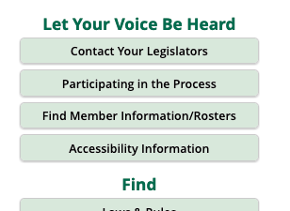 |  | to link to https://leg.wa.gov/legislature/Pages/Participating.aspx
On this Participating in the Process page under  Participating in ​a Committee Hearing  in the right column, click on any of the three options:  - Testifying in a Committee Hearing  - Submitting Written Testimony to a Committee  - Get Your Position on a Bill Noted for Legislative Record |  | 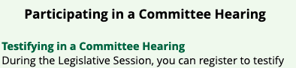  All three take you to the Committee Sign In (CSI) page, https://app.leg.wa.gov/csi
On the Committee Sign In page, select the chamber considering the bill.  Early in the session HB bills will be in the House, SB bills in the Senate. After passage in the house of origin HB bills will be in the Senate and SB bills in the House. | 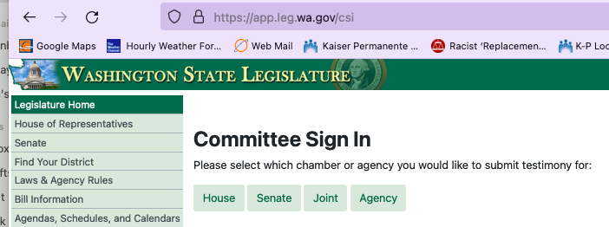
Each house has a page like this  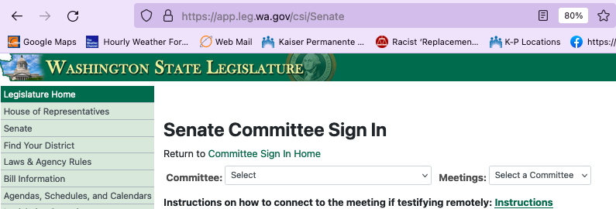 |  |  |  | Select the committee the bill of interest is being heard by  and the date of the hearing
to get to a Committee Sign In page

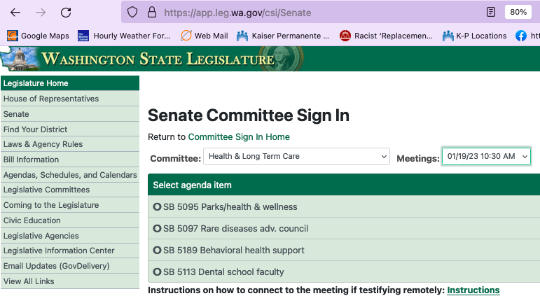
Selecting the bill of interest here reveals more information

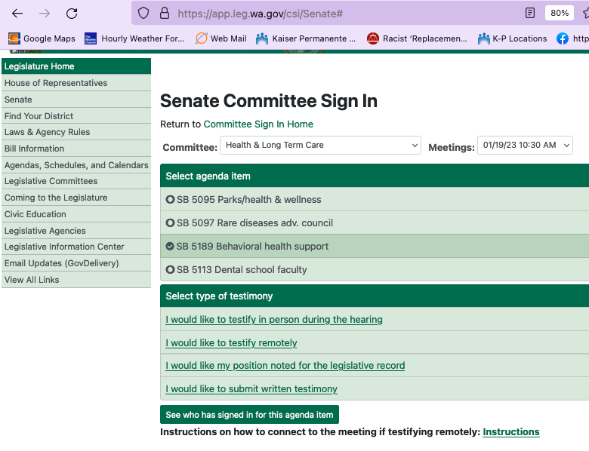
See who has signed in for this agenda item
Click on to find the information you seek.

