Washington Recycling And Packaging --The Re-WRAP act, HB 2049/SB 6005
January 20, 2024

The Re-WRAP ACT

HB 2049 and the companion bill SB 6005 are nicknamed the Re-WRAP Act because they are the next version of last session’s WRAP act. Last session, the House bill made it to Rules and the Senate version stalled in Ways & Means. On January 18th of this year, HB 2049 was passed out of the House Environment & Energy Committee with minor amendments. SB 6005 is scheduled for a public hearing in the Senate Committee on Environment, Energy & Technology on January 23.

What’s the point?

Reports commissioned by the legislature show that Expanded Producer Responsibility (EPR) systems combined with increasing post-consumer recycled content in products and other strategies can substantially increase waste recovery rates. Rates have been static since 2011 and are not meeting the statewide goal of 50% recycling established in 1989. In general, EPR systems put responsibility for dealing with waste on the producers of the products.

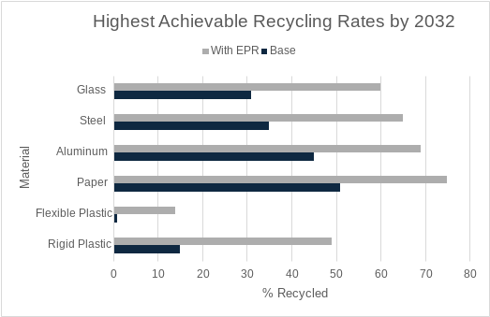

Source: Washington Recycling, Reuse, and Source Reduction Target Study and Community Input Process Report to the Washington State Legislature Ecology Publication 23-07-060 - December 2023

What does HB 2049/SB 6005 do?

- Producers of paper and plastic products must form a group, called a Producer Responsibility Organization (PRO), to carry out their prescribed responsibilities for managing waste, including bringing overall recycling rates up from 40% to 66%
- Under Department of Ecology oversight, the PRO must fund and support investments in education, outreach, infrastructure and market development as needed to achieve convenience standards, management standards, and performance rates.
- The PRO is required to track, verify and report on the responsible management of products that become waste. Convenient collection services must be available in every jurisdiction. Anyone who has curbside garbage pick-up will also be provided with curbside recycling.
- New programs will integrate with existing recycling programs conducted by cities and counties.
- The Department of Ecology will decide the final list of items covered under the bill, but in general, it covers packaging and paper products sold or supplied to consumers for personal, noncommercial use.
- The bill requires post-consumer recycled content (PCRC) for some products for which PCRC is not currently required and raises the amount of PCRC required in other products.

Talking points

- Waste plastic is ubiquitous, on the land, in the soil and in the oceans. Importantly, microplastics are in what we eat and in the air we breathe. Now is the time to implement new ways of limiting and recycling plastics.
- Packaging materials, especially plastic, are typically manufactured in southern states with employees who are low-income people of color. Communities of people who are poor, rural, Black, Indigenous, and People of Color have been disproportionately polluted by these industries, driving major social injustices and public health crises.
- Extended producer responsibility (EPR) systems are successful in Oregon, California, Canada and Europe and are recommended by the United Nations as an important tool to reduce plastic waste. HB 2049/SB 6005 bring EPR to Washington along with improvements in post-recycled content requirements.
- In Washington, overall recycling rates have stalled at about 49%. Studies prepared for the legislature show that Extended Producer Responsibility programs could raise this figure to 66%.
- Today, consumers have no control over the products that are manufactured yet they are responsible for recycling them. By making producers responsible for the cost of the recycling system, and for its performance, producers will have an interest in making products that are easy to recycle.
- Currently about 58% of Washingtonians have access to curbside recycling. Eleven counties have no access to curbside at all. HB 2049/SB 6005 brings curbside recycling to everyone who has curbside garbage pickup.
- Local governments and rate payers currently pay for recycling systems. HB 2049/SB 6005 transfers these costs to the manufacturers of packaging, while integrating new programs into existing recycling programs provided by local governments.
- HB 2049/SB 6005 also includes policies on improving the amount of post-consumer recycled material.

Sources for this document include: Public Testimony at the House Environment & Energy Committee on January 9 2024; the Bill Analysis for that meeting, and Washington Recycling, Reuse, and Source Reduction Target Study and Community Input Process Report to the Washington State Legislature Ecology Publication 23-07-060 - December 2023.

